ASSIGNMENT-1

Creating a Circuit using Sensors ,Buzzer & LED’s

|  |  |
| --- | --- |
| Assignment Date | 9th September 2022 |
| Student Name | Nirsitha R |
| Student Roll Number | 737819ITR055 |
| Maximum Marks | 10 Marks |

Int blueLED1 = 2;

Int yellowLED2 = 3;

Int greenLED3 = 4;

Int redLED4 = 5;

Int buzzer = 6;

Void setup()

{

pinMode(blueLED1, OUTPUT);

pinMode(yellowLED2, OUTPUT);

pinMode (greenLED3, OUTPUT);

pinMode(redLED4, OUTPUT);

(buzzer, OUTPUT);

digitalWrite(buzzer, HIGH);

}

Void loop() {

digitalWrite(blueLED1, HIGH);

delay(50);

digitalWrite(blueLED1, LOW);

digitalWrite(yellowLED2, HIGH);

delay(50);

digitalWrite(yellowLED2, LOW);

digitalWrite(greenLED3, HIGH);

delay(50);

digitalWrite(greenLED3, LOW);

digitalWrite(redLED4, HIGH);

delay(50);

digitalWrite(redLED4, LOW);

digitalWrite(greenLED3, HIGH);

delay(50);

digitalWrite(greenLED3, LOW);

digitalWrite(yellowLED2, HIGH);

delay(50);

digitalWrite(yellowLED2, LOW);

}

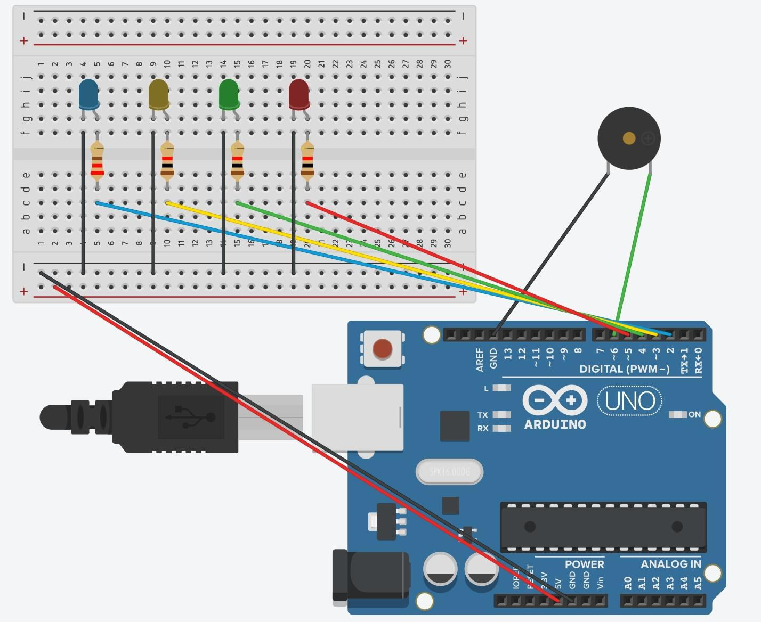OUTPUT: